

**Course Title: Object Oriented Programming**

**Course code: CSE110**

**Mini Project: Develop a simple Calculator that can perform four basic arithmetic operations such as +, -, /, and * using JavaFX GUI programming.**

**Submitted to**

**Course Instructor**

**Dr. Anup Kumar Paul,**

**Associate Professor**

**Department of Computer Science and Engineering**

**Submitted by**

**Name: Md Ahsiul Karim**

**ID: 2022-3-60-074**

Project output:

After run the project code we get this output

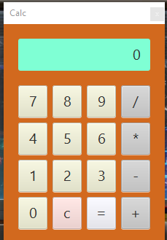

Then I have taken some values input in this calculator. I take a sample values as 12

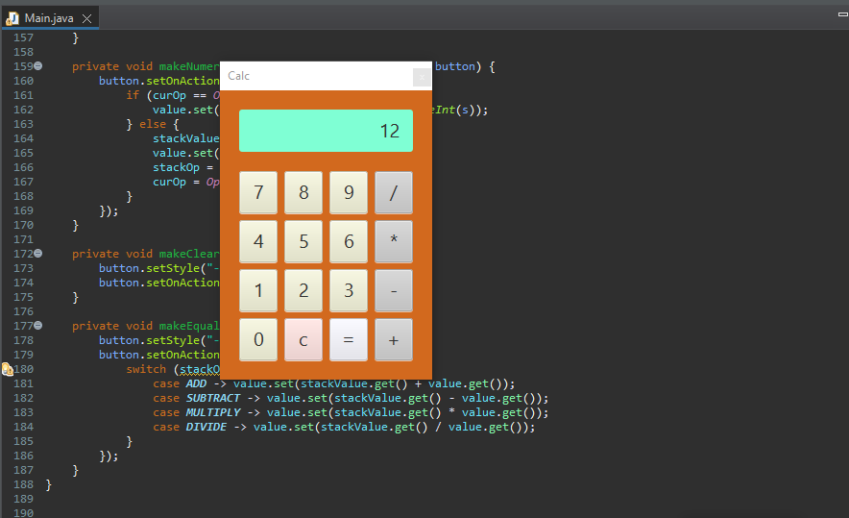

After that I have taken another values from the user as 13

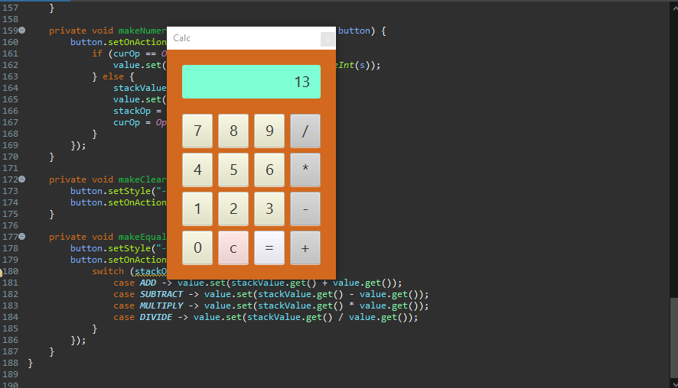

The final output of addition of 12 and 13 is given below

